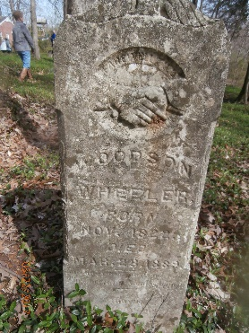
Woodson Wheeler Biography
Woodson Wheeler’s military record states he was born in 1821 in Buckingham County, Virginia. Later the census records would list his birthplace as Kentucky. This is understandable as in all probability he came to Kentucky early in his life. His owner Elizabeth Watkins was born in the same county as Woodson and brought him to Kentucky after marrying Dr. James Wheeler. They settled in Christian County, Kentucky on a 445-acre farm named “Richland.” This farm was not far from the Tennessee state line. In January 1864, Woodson escaped to the recruitment camp of the 16th USCT located in New Providence not far from present day Ft. Defiance. There on January 22, 1864, the 43-year-old 5-foot 5-inch farmer joined Company H, 16th USCT for 3 years. He was described as having copper skin and black hair and eyes. His military record shows his rank as cook.
On March 31, 1864 Woodson was listed as deserting in Clarksville. This is about the time that the 16th USCT was leaving Clarksville. In May, the Army charged him $23.90 for his uniform. On September 15, 1864, Woodson rejoined his unit at Chattanooga. The January/February 1865 roll notes he was awaiting trial on charge of desertion. By March/April 1865 he was waiting the sentence of Court Martial. He was acquitted of the charge of desertion but found guilty of absence without leave for 20 days. He was fined one month’s pay plus loss of pay and allowances for the 20-day absence. May/June 1865 found Woodson sick in quarters, and the January/February 1866 roll showed that the government owed him $21.21 for transportation. When Woodson mustered out on April 30, 1866 and this $21.21 is all that the government owed him.
Woodson returned to Clarksville after being mustered out because on November 5, 1866 he married Amanda McCurtis in Montgomery County. The 1870 Census shows Woodson and Amanda living in the 9th Street, 10th Street, Franklin Street corner of Clarksville. They have four boys living with them: Jerry, age 14; Richard, age 18; Walter, age 21; and Robert, age 6. This possibly explains his desertion. If these are Woodson and Amanda’s sons, which is highly likely, their ages indicate that Woodson and Amanda were man and wife during slavery. Woodson could have spent his 20 day absence getting his family to Clarksville.
The Montgomery County 1870 census was taken in June 1870. In July 1870, Woodson appears in the Christian County, Kentucky census in the same area as his old master’s farm working as a farm laborer and living with nine other unconnected people. None of his family that appeared on the Montgomery County census are with him. This possibly indicates that he left his family in Clarksville and returned to work on Dr. Wheeler’s farm.
The1880 census shows him back in Clarksville but the only member of his family living with him is Jerry who is now 23 years old. They are both listed as laborers. Curiously, on the census Jerry’s gender is obviously changed from male to female and he is listed as Woodson’s wife.
The last document found on Woodson is an unused marriage license dated 12 March 1881 for Woodson to marry Nancy Campbell. The note on it is “This license destroyed not used.” Nancy Campbell was a 30 year old widow who was living in the same area as Woodson. The reason the marriage was called off is unknown. Nancy died in 1916 and was buried in Mt. Olive Cemetery.
Woodson Wheeler died on March 28, 1889. He was 66 years old.

