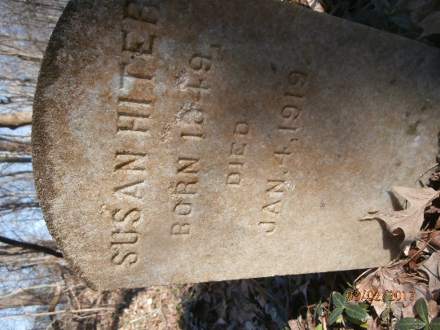
Susan Hite Biography
Susan Hiter was born Susan Warfield in Kentucky in 1849. Currently there is no information on her parents or where precisely she was born. The first record that mentions her is a marriage record to Osborne Hiter. They were married in Montgomery County on August 31, 1865.
When Osborne Hiter died is unknown. In a deposition, Susan stated he died shortly after the war ended. She then “took up” with Thomas Bristol who was a USCT veteran of Company B, 16th USCT. A deposition supporting her claim for a widow’s pension puts the beginning of their relationship in 1869. They lived together as man and wife until his death on January 4, 1870. Their only child Thomas Bristol, Jr. was born July 1, 1870. An 1895 Clarksville City Directory shows her living at 124 University Avenue which is the address given in all the paperwork in her pension application.
In April of 1890, Thomas Jr. applied for a minor’s pension which was never awarded to him. In 1892, Susan applied for a widow’s pension. She had depositions attesting that she and Thomas Bristol were man and wife, and attempted to secure the paperwork that the pension office demanded. They sent a Special Examiner to Clarksville to investigate her claim, and this probably frightened her into admitting that she and Thomas were never married. She stated she was talked into applying for the pension by R. D. Newton who was in jail for pension fraud. She acknowledged that Newton had told her she would have to prove her marriage but claimed that if any of the paperwork said she and Thomas were married it was a mistake and she had never claimed it. She contended that Newton had put it in the paperwork. She just signed what he told her to sign, and since she could not read or write, she trusted his word on what was in the documents. The Special Examiner sent a short report back stating at this point, he ceased looking into the claim since she wasn’t eligible for a pension. This probably was also the reason Thomas Jr. did not receive a pension.
There are three letters in the pension record to various people from Susan Hiter that seem to indicate she was more aware of the attempt to prove her claim than she indicated to the special examiner. All three letters start the same: “I am a poor widow”. One written to U.S. Senator William B. Bates asking him to check on the status of her claim. Another written to John R. Blair of West Virginia who was the regimental surgeon asking for any information on her husband’s disabilities during the war. The final one to the pension office stating she has sent all the evidence she had to their office twice. All three are written in different hands, but there is no indication in the letters that Susan didn’t write them herself. At one point in the paperwork, she tells the pension office she cannot furnish them with proof of her marriage to Osborne Hiter because the courthouse burned in a fire in 1878.
On October 7, 1898, Susan claimed that she was assaulted by Neal McFall, a black barber. That afternoon the case was tried before Squire Caldwell. Susan claimed McFall attempted to strike her. The result was McFall was fined $10.
The 1900 Montgomery County census shows Susan living at 218 University Avenue with three of her daughters: Clemmie Hiter, born 1878 and working as a servant; Willie Hiter, born 1883 still at school; and Jessie Hiter born 1899. Susan was working as a cook.
By 1910, Susan was living at 219 Sixth Street working as a cook. Thomas Bristol, Jr. was living with her and working as a porter in a club room. Another son, Clarence Hatcher and his wife Goldie were also living with her. Clarence was working in a snuff factory, and Goldie was working as a laundress in a school. Susan also had a boarder, Charlie Meriwether who also worked in a snuff factory.
The 1911 Clarksville City Directory revealed that Susan was working for J. A. Lyons as a cook and that her address had changed to 229 Sixth Street.
Susan Hiter died on January 4, 1919 of Dysenteric Diarrhea that had plagued her for some months. She was buried in Mt. Olive Cemetery the next day by William Keesee. Her headstone in Zone 8 is simple but professionally carved.

Bibliography
“Assault and Battery.” Clarksville Daily Leaf-Chronicle. October 8, 1898.
Clarksville, Tennessee, City Directory, 1895, 1911
Pension file 566981, Bristol, Thomas, Civil War, National Archives Building, Washington, D. C.
U. S. Census Bureau, “Montgomery County, Tennessee 1900 & 1910 Census.”

Following the shooting of an unarmed black man by a police constable, a fire in downtown Clarksville started. The fire originated in a wooden building behind a business on Franklin Street, and by the time it was extinguished, 15 acres of downtown had burned. The courthouse burned but most of the records were removed in time.

