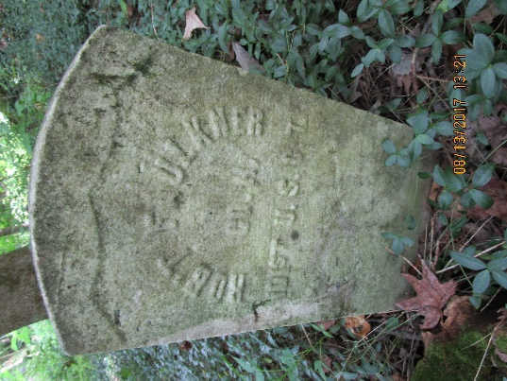
Roderick and Margaret Faulkner Biography
Roderick Faulkner was born in Trigg County, Kentucky in 1838 to Sarah Faulkner and both were owned by Dr. Hutch Faulkner who lived about four miles from Port Royal. His future wife Margaret was born in 1843 in Robertson County, Tennessee and belonged to Tom Bowen. Tom Bowen’s place was about four miles from Dr. Faulkner’s so the two knew each other from childhood. While they were still slaves, Roderick and Margaret were married in the summer of 1862 by Kit Humphrey, a black preacher. The ceremony took place in Tom Bowen’s yard. The couple would go on to have 12 children but only one survived after the parents died. Unfortunately, we only know the names of three of the children.
Roderick enlisted in Company H, 101st USCT on January 15,1865 in Clarksville and seems to have spent his entire term of service here. The 27-year-old was described as 5 feet 10 inches tall, black hair and eyes with a yellow complexion. The March/April 1865 muster roll notes that he was absent sick in hospital at Clarksville, Tennessee since March 25, 1865. On September 1, 1865, Roderick was promoted to sergeant. His military career came to an end when he was mustered out of the Army on January 24, 1866 in Nashville. The Army owed him $3.15 in pay, and paid him a $100 bounty.
Roderick and Margaret are listed in the 1870 Montgomery County, Tennessee census with two daughters: Eliza born in 1866 and Phebe born in 1868. In 1870 they added another daughter, Mannerva to the family. They lived at 216 Poston Street in a house described as a small rudely constructed frame cabin which was probably built by Roderick himself. The house was renumbered several times as Clarksville grew. In 1910 it was renumbered 132 and in 1911 it was renumbered 415. In the 1870 census, Roderick was working as a grocer and by 1880 he was listed as a laborer.
The community of USCT veterans seems to have been mutually supportive. In February of 1890, Roderick witnessed a deposition that John Christian and Thomas Campbell gave supporting William Logan’s application for a pension. By this time, Roderick was 52 years old and suffering from heart disease. Dr. N. L. Camey diagnosed him with organic heart disease due to exposure and wrote a deposition to that effect in support of Margaret’s application for a widow’s pension. During the last two weeks of his life, Roderick was confined to bed. Margaret described his death on July 1,1890 as follows: “He got up, and walked out, and fell dead in the garden.” His daughter Phebe died in 1898. It is unclear when Eliza died and there is no record of where either of them is buried.
Margaret found herself living alone in the family house in 1900 working as a laundress. She owned the house outright with no mortgage. In the 1910 census, she is still living alone but is no longer working very likely due to her widow’s pension which she applied for in 1900. By 1920, Mannerva, her sole surviving child, is living with Margaret in the family home along with her husband Reed Smith and their daughter Maggie.
Margaret died on August 31, 1925 of a perforating ulcer and was buried in Mt. Olive by Nace Dixion’s Undertaking Company. She was 82 years old. The total cost of her funeral was $170. At the time she died, her widow’s pension paid her $30 per month.

