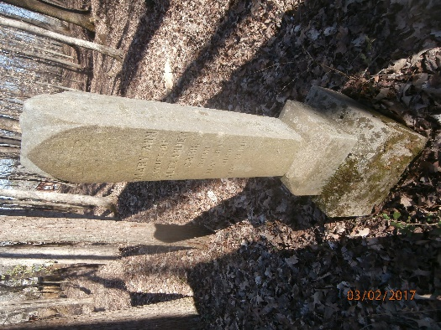
Mary Ann Carr Biography
Mary Ann Carr nee Teasdale was born in 1849 in Logan County, Kentucky. On April 24, 1869, she married Alexander Carr. Together they had five children but only two of them lived to adulthood. The 1880 Census lists her children as Ever Carr a female age 10 years old and Eugeen Carr a male age 4. By the time of the 1900 Census, Ever had left home and only Alexander, Mary Ann, and Eugene remained in the Carr household. Eugene’s occupation was listed as School Teacher. Alexander’s occupation was listed as body laborer. In her will, Mary Ann notes that they purchased a house on Ford Street from Dr. N. L. Carney on June 24, 1893.
In the 1900 census, the Carr family were living at 219 Ford Street in Clarksville and are recorded as owning their home free of a mortgage. Alexander died in 1903. By the 1910 Census, Eugene was not listed as living with his mother. Mary Ann’s occupation in 1910 was cook in a boarding house. She had two grandchildren living with her. Annie Childres, aged 15, is listed as her granddaughter and Charlie Childres, age 14, is listed as her grandson. The 1911 Clarksville City Directory lists both Mary Ann and Eugene living at 424 Ford Street. Mary is listed as a cook, and Eugene is listed as a laborer.
Mary Ann died of cancer on May 23, 1912. She was 63 years old. On April 8, 1912, Mary Ann made out her will leaving all she possessed to include her house to her son Eugene, her daughter Eva Jane Hogan, and her granddaughter Annie Childress.

