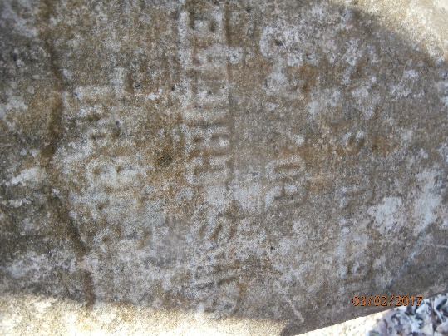
Charles Griffey Biography
Charles Griffey was born in 1840 in Columbia, Tennessee. He was owned by George G. Griffey and spent most of his life on a farm in Noah Springs, Kentucky which was in Christian County, Kentucky not far from the state line with Tennessee. While a slave, he had a wife named Sue Kendrick with whom he had a daughter named Charley Ann. Slave marriages were not considered legally binding and this one was even less binding due to the fact that George Griffey did not give his permission for Charles to marry. He apparently snuck out at night to go see Sue who was owned by Smiley Kendrick.
On February 16, 1864, Charles crossed the state line and came to Clarksville, Tennessee and enlisted in Company A, 16th USCT. He is described as 24 years old, 5 feet 2 inches tall, with brown complexion and hair and black eyes. He enlisted for 3 years. The 16th USCT spent almost all of its existence in Chattanooga, Tennessee. On the January/February 1865 muster roll, Charles is charged $1.25 for a canteen (45 cents) and two haversacks (80 cents). He was promoted to corporal on April 1, 1865.
The 16th USCT was ordered to Nashville, Tennessee in December of 1864 in response to Hood’s advance on that city. The 16th USCT fought in some initial skirmishes but was held in reserve during the battle. After the battle, Company A, 16th USCT, marched back to Chattanooga from Nashville. According to Charles’s bunk mate, this march took 12 to15 days and this is when his bunkmate noticed that Charles had problems with rheumatism. He stated that Charles walked bent over, and frequently had to use two sticks to walk. Many of his comrades stated in their depositions that Charles complained of rheumatism pains while in the Army and that he went to the regimental doctors to get medicine for it.
He was mustered out in Nashville on April 30, 1866 and owed the government 87 cents, and apparently the government did not owe him any money. He did not come straight to Clarksville after mustering out. Delia, his wife, states that he went to St. Louis to see his mother. He was back in Clarksville by 1867 because he married Delia Elder on August 3, 1867 in the basement of the white Methodist Church. Dr. Taylor presided over the ceremony. Delia had belonged to Joshua Elder who sent his slaves to a cousin in Little Rock, Arkansas when the war broke out. She came back to Clarksville in December of 1864. She met and became engaged to Charles while he was still in the Army. His relationship with Sue Kendrick had ended when he joined the Army by mutual consent.
Charles built a house at 146 Commerce Street in Clarksville soon after they married. He worked at Winfield Rove’s stable until his rheumatism began to cripple him. First his feet and legs caused him problems, then it moved to his spine. He stopped working at the stable in the fall of 1867. When he was able, he worked as a painter because he could no longer do heavy work. In April of 1885, Charles went to see Dr. Charles Wilson who diagnosed him with locomotor ataxia which is described by Wikipedia as “the inability to precisely control one’s body movements.” Patients walk in a jerky, non-fluid manner and don’t know where their limbs are unless they look. This is a condition often connected with syphilis. Dr. Wilson only treated him a short time before his death. He did state in a deposition that he saw no other signs of syphilis and that the condition could be caused by other health issues. When Delia applied for a pension, the special examiner asked tactful questions of the people being deposed which were designed to see if Charles showed any signs of syphilis. No one had seen any signs of this disease.
Towards the end of his life, Charles was so crippled that he was confined to his house. He died there on February 6, 1888 at 6 pm. He was buried in Mt. Olive by Henry Roberts and the grave was dug by George Vance.
Delia got her pension and appears on the 1900 census living in their house with her widowed Sister-in-law and her nephew. Delia died on May 21, 1918.
As a side issue, when Delia first applied for a widow’s pension, her local lawyer was R. D. Newton. He is described as a crippled black lawyer. R. D. Newton’s name appears in several pension records. According to Delia, Newton convinced Charley Ann, Charles’s daughter, to apply for some of his pension money. On April 17, 1895, R. D. Newton was convicted of pension fraud and was sentenced to 13 months in jail.

