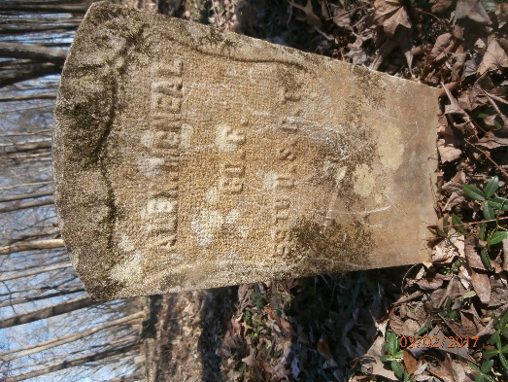
Alexander McNeal Biography
Alexander McNeal was born in Hartman, Tennessee in 1845. The names of his parents are not known but his pension record lists two brothers: Lee and Napolein McNeil and a sister, Emma Calyten. His life is one confusing mystery after another. The name of his master is unknown but after he fled slavery, he stayed in Memphis for a short time, probably working as a civilian laborer. Eventually he enlisted in the Army on June 1, 1863 at Bolivar, Tennessee for three years. The unit he joined was Company C, 1st Regiment West Tennessee Infantry African Decent. Basically, he was among the first recruits to the unit which was mustered in at La Grange, TN later that month. On March 11, 1864 in accordance with the new Army policy of standardizing unit designations for black regiments, it became the 59th USCT. He is the only member of this unit buried in Mt. Olive Cemetery.
The new soldier was 18 years old when he joined and was 5 foot 6 inches tall with black hair and eyes and black complexion. Before he became a soldier, he was a farmer. Alex spent the first part of his life and most of his Army career around the Memphis area. The first mystery is what brought him to Clarksville.
The Unit stayed in La Grange until August 1863 when it proceeded to Corinth, Mississippi where they stayed for the rest of the year. They returned to Memphis in January 1864. In June the unit returned to Mississippi. They were part of the expedition commanded by Brigadier General Samuel D. Sturgis which ended in a Union defeat at the Battle of Brice’s Crossroads. Alex had been listed on the March/April 1864 roll as on detached service since April 2, 1864 but was back in the unit by the May/June 1864 roll so he would have participated in this expedition. The regiment lost 3 officers and 143 men. Company C lost 1 First Lieutenant, 1 private killed, and 1 private missing.
In July 1864, the unit was part of the Tupelo Expedition commanded by Major General Andrew J. Smith. The unit was engaged in the Battle of Harrisburg, Mississippi on July 14, 1864. The regiment lost 1 killed, 10 wounded, and 3 missing. On July 15, 1864, the regiment started its march back arriving at La Grange on July 21. From there they returned to Memphis by railroad and arrived on July 23, 1864.
Company C again left Memphis on an expedition commanded by Major General Smith. On August 3, 1864 they left for Oxford, Mississippi arriving on August 21. On the same day, they turned around and went back to Memphis arriving on August 30. The company records reported no enemy engagement and that they marched 170 miles. This was the company’s last expedition. The unit was assigned to Ft. Pickering in Memphis until it mustered out.
On the November/December 1864 roll, Alex was on detached service at General Chetlain’s headquarters starting on December 8, 1864. This lasts through the January/February 1865 roll, but the March/April 1865 roll lists him absent under arrest since January 14, 1865. In his record is Special Order number 129 which releases him from arrest and restores him to his unit. The rest of his record lists him as present with his unit until the November/December 1865 roll which shows him absent on furlough for 10 days since December 20, 1865. Alex mustered out on January 31, 1866.
The special examiner’s report in his pension record states that he did not come to Clarksville immediately after discharge and that he does not know where the soldier was during this time period. By 1870. Alex was in Montgomery County living northwest of the Ringgold area probably close to the state line (per Montgomery County Archivist Jill Hastings). He was living and working on Lou Clardy’s farm.
The 1880 census gives another mystery. Although all of the depositions in Alex’s pension records say that he never was married before 1885, the census lists him as living in New Providence with a wife named Dicy and a 3-year-old daughter named Sue. There is only one marriage record for Alex and that is in 1885. It is possible that they had just “taken up together” and they either went their separate ways or his wife and child died.
On July 6, 1885, Alexander McNeal married Mary L. Moore at Steel Springs, Montgomery County, TN. They were married by a black preacher named Abe Wimberly who lost their original certificate and had to get them a second one. Mary states in her deposition that she knew Alex for 6 or 7 years before they married. This is another mystery because this would mean that she knew him while he was with Dicy. Also, Steel Springs is across the Cumberland River in the Cumberland Heights area in a bend of the river that isn’t close to any ferry. If Mary lived in this area before they were married, courting would have been difficult.
By the 1891 Enumeration, Alex and Mary were living in Clarksville proper probably at 68 Marion Street. His pension records describe Alex as owning a lot with a small house valued at $300 which was mortgaged to a Clarksville Building and Loan Association. He applied for a pension on May 21, 1892 and was awarded $6 a month for rheumatism and disease of the heart starting on December 6, 1892. He and Mary had one child who was still-born. Alexander McNeal died on February 5, 1895 at his home of consumption. He was 48 years old and was working as a barber probably for Buck’s Barber Shop when he died. The Clarksville Leaf-Chronicle reported that Abe Smith, a colored bootblack who once worked at Buck’s Barber Shop disrupted Alex McNeal’s funeral on February 6th with “very indecorous conduct” and outlandish behavior.
Mary McNeal applied for a widow’s pension and received one starting on February 8, 1897. When her pension was discontinued, she was receiving $8 per month. Mary married William Collier on November 17, 1898 and the 1900 census shows them probably living in the McNeal house. The census lists them as renting the house. Currently this is the last record found for them.

