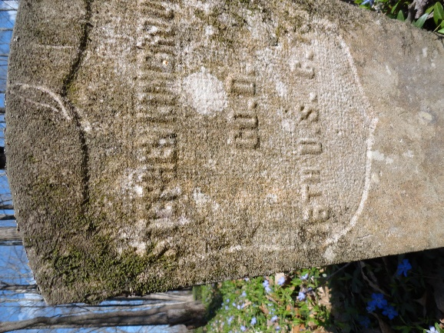
Stephen and Irene Kimbrough Biography
Stephen Kimbrough was born into slavery near Allensville, Todd County, Kentucky in 1836. His master was Gaff Kimbrough and he does not seem to have married during his bondage. At 28 years old, he escaped slavery and came to Clarksville, Tennessee and joined Company D of the 16th USCT on February 16, 1864. His military record describes him as 5 feet 7 inches tall with brown complexion and eyes and black hair. Later a coworker in a deposition would describe him as a big stout man. Unsurprisingly, his pre-army occupation was as a farmer.
His military record is unremarkable except for a note that in August 1864 he was on duty at work with Captain Giffin. His medical record shows that he was treated for intermittent fever on November 24 and December 6, 1864. He was treated for pleurisy on November 30 and December 3, 1864. On November 30, 1864 he was treated for lumbago.
He was with the 16th USCT during the Battle of Nashville. The regiment was held in reserve during that battle. Depositions in Stephen’s pension records state that the 16th skirmished with Confederate Generals Forrest and Wheeler at Pulaski, Tennessee. The conditions were very bad for the soldiers. They dealt with snow, mud, and very cold temperatures. Stephen stated these conditions gave him a severe cold. These conditions probably caused the pleurisy noted in his medical record.
Stephen was mustered out of the Army on April 30, 1866 in Nashville. The Army owed him $25.49. After leaving the Army, he returned to Clarksville where on May 21, 1866 he married Arabella “Bell” Gill. They must have known each other before the war based on two things: the short time between returning to Clarksville and their marriage, and the fact that Bell was also from Allensville, Kentucky. Stephen got a job at Kellogg’s Saw Mill, and the couple settled down in Clarksville. They had two years of married life. Bell got very ill before she died, and her mother, Fanny Gill, came to Clarksville and took her back to Allensville to nurse her. Bell died on May 15, 1868. Stephen’s coworkers describe him as immediately quitting work when he heard the new so that he could go to Allensville and bury her.
Stephen continued to work at Kellogg’s Saw Mill and was working there still when he married Irene Herring on March 22, 1871. Irene had been a slave of John Kessee and had married William Steele while they both were slaves. She stated that they were married the year of the “Negro riot in Tennessee.” This would probably put her marriage in 1857. There were rumors of a slave uprising all over the South with much of it centered on the iron furnaces in this area. William Steele or Thompson (he went by both names) died during the war. He was a carpenter who was working on the railroad bridge over the Cumberland River when he fell off the bridge and drowned. They never recovered his body. Irene and William had at least one son named Nerral.
On July 21, 1869, Irene married Lewis Herring. One year and four months later, he died. This places the date of his death in November of 1870. They say that the third time is the charm. Irene states that she was introduced to Stephen by her brother-in-law, Dan Martin. Dan was also a USCT, and he and Stephen returned to Clarksville together.
Around 1874 or 1875, Stephen left Kellogg’s Saw Mill and began working for Gracey and Brother at the freight depot. He would work at the depot until his death. The 1880 census shows him living in District 12 with Irene and four children: Henry, age 8; Eddie, age 7; Bell, age 10; and Clarence, age 2. On April 27, 1885 George Stephen Kimbrough was born and the following year on March 13, 1886, their last child, Louisa was born. There is an older son, Norman, who doesn’t appear in the 1880 census. His birth year is unknown but he seems to have been old enough to go out on his own. In 1892 the family was living at 603 Franklin Street. At some point after that, he acquired two lots: one on Paradise Street where he had moved the family by 1894, and one on Taylor’s Hill in Ward 9. Currently, Taylor’s Hill has not been identified. The lot on Taylors hill had a small frame house with one room and a kitchen which they rented out. The Paradise Street house was a two-story frame house with four rooms.
Stephen joined the Odd Fellows Lodge and was a person of influence in his community. On February 23, 1891, he gave a deposition in support of Mary Watkins, wife of Given Watkins, in her quest to obtain a widow’s pension. On November 22, 1892, he gave a deposition for Barry Gupton, a well-to-do former USCT, in his quest for an invalid’s pension.
Stephen, himself, applied for a pension on May 4, 1891. For quite a number of years, he complained of chest and back pain and shortness of breath. He was treated for these complaints by R.G. Martin, a black doctor living in Clarksville. He received a pension and at his death was receiving $8 per month. On February 13, 1896, Stephen went upstairs to lie down for an hour. When they went to call him for dinner at 12 o’clock, he was dead. This was a surprise for he had been out and about the day before. The cause of death was organic heart disease. He was 61 years old. Two of his children, George and Louisa, were below the age of 16 years old when he died and received minor’s pensions of $2 per month until they achieved the age of 16. On May 5, 1896 Irene applied for a widow’s pension which when it started paid $8 per month. After her husband died, Irene worked as a laundress.
The 1900 census shows Irene, Clarence, George, and Louisa living at 32 Paradise Street. By 1910, Irene, George, and Louisa were living at 419 First Street. The census indicates that Irene owned the house free of mortgage. On February 8, 1911 George married Bessie W. Whitfield and the couple moved in with Irene and Louisa. In 1911 Irene was working as a laundress, George was a laborer with the L & N Railroad, and Louisa was working as a sick nurse. Norman was living with wife, Annie in 627 South Second Street and was working as a mail carrier.
Irene Kimbrough died on July 2, 1914 of ulcerative bowels complicated by dysentery. Her death certificate says she was born in South Side, Tennessee, and her father was Ike Kessee. She was buried in Mt. Olive Cemetery on July 4, 1914. At the time of her death, her pension had risen to $12 per month. George Kimbrough spent the last years of his life in Central State Hospital in Nashville. This hospital was an insane asylum. He died there on September 7, 1924 of myocarditis with a contributing factor of general paralysis of insane. He was buried in Clarksville but the cemetery is unknown.
Norman lost his wife Annie, exactly when is unknown, but on February 28, 1920 he married Mattie Gibson. Norman was a decon at St. John’s Baptist Church which still exists on Tiny Town Road. He was a member of numerous lodges and continued to be a letter carrier until just before his death. Six weeks before he died, he collapsed on his route. He died of chronic valvar heart disease at 2 am on February 14, 1926. He is buried in Golden Hills Cemetery.
Edward Kimbrough moved to Chicago and married a woman who was a physician. He was in Clarksville visiting Norman and was present when he died. After the funeral, Edward returned to Chicago. So far, no record on Louisa has been found past the 1910 census. This can probably be explained by marriage.
The house on Paradise Street does not exist today. Neither does Paradise Street. Valleybrook Park now occupies the area where Paradise Street once stood.

