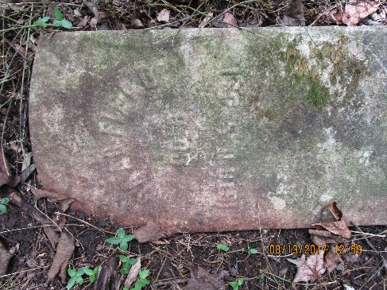
Isaac Fields Biography
According to the 1880 Census, Isaac Fields was born in 1838. He joined Company D, 16th USCT on December 24, 1863. His Descriptive Roll states he was 22 years old with black hair, brown eyes, and brown complexion standing 5 feet 7 inches tall. He was born in Montgomery County and joined the Army in Dover, Tennessee. His occupation when he joined was farmer. Unusually, when he mustered in he was given the rank of Corporal.
Company D of the 16th USCT spent its existence in Chattanooga, Tennessee, and it seems so did Isaac Fields. On the July/August 1865 Muster Roll, he is listed as in confinement at Chattanooga, Tennessee since August 27, 1865. His pension records show he was reduced in rank to Private on June 26, 1865. Muster Rolls indicate he was back with his company in September/October 1865.
Isaac Fields was mustered out of the Army in Nashville, Tennessee on April 30, 1886. His military record shows that he owed the government $4.67 on his clothing account. The next record found on Isaac Fields is the record of his marriage to Hannah Steger on 29 August 1875. At this time, he was living on Lewis Bower’s farm in St. Bethlehem near the old fairgrounds. Both he and Hannah worked on this farm and during the time they were there, their son, Floyd, was born. According to her petition for a widow’s pension, Hannah states that two years after Floyd was born they had a second son who lived just one week and a day. In 1880, they were living in downtown Clarksville according to the Census his occupation was laborer. He was 42 and living with Hannah and Floyd now aged 5. In Hannah’s statement for her pension request, she stated that Isaac earned his living as a brick maker.
Shortly before his death, Isaac and Hannah separated. According to statements made by Hannah and their neighbors and friends who gave depositions in her application for a pension, they had a very stormy marriage. It seems Isaac was a lady’s man. Testimony paints a picture of a man who ran around with women quite a bit before his marriage and did so after his marriage as well. In depositions, Charity Bradly stated “She could not stand him. He was awful mean to her.” Shelby Barker stated “She belonged to the church and he didn’t.” Monroe Warfield who was raised by Hannah and was living in the house at the time testified that Isaac came home drunk and beat her. She knocked him in the head, and he bundled up his clothes and moved in with another woman. He remained with this woman until just before his death when he moved in with his sister, Arlensen Ligger, who lived on Franklin Street. Statements in the pension request indicate that Isaac’s spine and kidneys were bad and that just before he died, he could hardly walk.
Isaac Fields died in his sister’s house. Most of the records state he died on July 26, 1890, and his wife stated he died at 6 a. m. In the pension application, C. W. Beaumont, Clarksville Health Officer who kept the mortuary record, stated that Isaac Fields died on July 15, 1888 and was buried in Mt. Olive by Henry Roberts on July 16, 1888. He states Isaac died of Bright’s Disease. Bright’s Disease is a kidney disease characterized by inflammation of the kidney, apoplexy (bleeding in internal organs), convulsions, blindness, and coma. It is diagnosed frequently in patients with diabetes.
In September of 1890 as a result of a change in the law, Hannah Fields applied for a widow’s pension. As a result of a problem with conflicting dates in statements in her application, her pension request was referred for investigation. During the investigation, attention focused on her morals and if she had lived with another man since Isaac died. In 1893, Hannah was living at 1119 Franklin Street. In 1898 she was living at 1020 Franklin Street. At this time that part of town was called “Scuff” Town and was inhabited by “lewd colored women”. It is clear from the questions asked by the investigator that just living there called her morals into question. Some of the people deposed made clear that there was a man living in her “house” which at the time consisted of two rooms, one upstairs from the other. Her landlord stated that this man paid the rent for her rooms for several weeks. She denied any cohabitation and stated that she allowed him to stay a short time in the upstairs room while she stayed in the downstairs room.
Her application for a widow’s pension was rejected for adulterous cohabitation since the death of the soldier. She applied for reconsideration in 1897 but was rejected again on the same grounds.
No further records have been found at this time either on Hannah Fields or Floyd Fields.
It is interesting to note that both William Logan and his wife Eliza gave statements on behalf of Hannah Fields. William is one of the USCT buried in Mt. Olive but was in a different regiment. Eliza is also buried in Mt. Olive.

