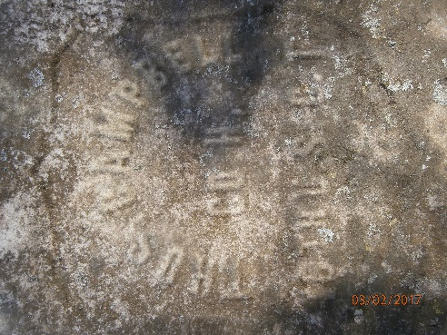
Thomas Campbell Biography
Thomas Campbell was born in Warrick County, Virginia in 1841. It is unknown how he came to Tennessee but during that time frame, Virginia and North Carolina became important in the exporting of slaves to other states since importing slaves from Africa was outlawed in 1808.
Thomas enlisted in Company H, 16th USCT on January 21, 1864 in Clarksville, Tennessee for a term of three years. He was 23 years old, 5 feet 5 inches tall with black hair and eyes and a black complexion. He had been a farmer before he enlisted. His service record is unexceptional until he was granted a 15-day furlough which started on November 24, 1865. He was charged $6.20 for transportation to and from wherever he spent his furlough. Most USCT units were kept on active duty until 1866 but after hostilities ended, the units granted furloughs wholesale to their troops. Otherwise, Thomas was never absent from duty and did not loose any of his equipment. Company H does not seem to have left Chattanooga at all during its time on active duty so Thomas would not have seen action at the Battle of Nashville. When he was mustered out of the Army on April 30, 1866, the Government owed him $11.38.
Thomas is listed in the 1880 Census as living in District 12 of Montgomery County, Tennessee. This district encompasses Clarksville City proper. Listed with him is his wife Sarah who was born in 1840. They have no children in the household and Thomas listed his occupation as Laborer.
Thomas knew and was friends with William Logan. He made a deposition for William Logan’s application for a pension dated February 10, 1890. In his deposition, Thomas attested to the fact that he knew William both before and after the war and could state from personal knowledge details of William’s health problems and their effect on William’s ability to do any labor. Thomas had worked with him and testified that William was unfit to do labor.
Thomas, himself, filed an application for a pension on August 11, 1890 and like so many of the Clarksville USCT veterans, his initial attorney was R. D. Newton who was paid $10 to forward his claim. His application stated that he suffered from dropsy and its results which left him unfit for labor. Dropsy is an old medical term that refers to the swelling of soft tissue that usually indicates congestive heart failure.
Thomas Campbell’s pension record is extremely brief and includes a mere 13 pages. His initial application was a standard form that indicates his unit of service, dates of service, reason for unfitness for labor, and details of who his attorney was. On April 9, 1891, Thomas had an appointment for a medical examination in Russellville, Kentucky. A note appears on this form stating “Claimant failed to appear within the specified time. A letter from a Clarksville attorney, J. W. Robarts with an office at 93 Strawberry Alley is dated July 11, 1892. He stated in the letter that the claimant was indebted and inquired about reimbursement of Thomas Campbell’s claim. This is the sum total of information in the pension record of Thomas Campbell.
The reason he did not appear at his medical examination was that he died on December 7, 1890. We can make the assumption that he died of his cardiac condition. We know the date that he died because someone asked the Federal Government for a USCT headstone for his grave. He may have left a small paper trail but his service in the United States Colored Troops left a large legacy.

