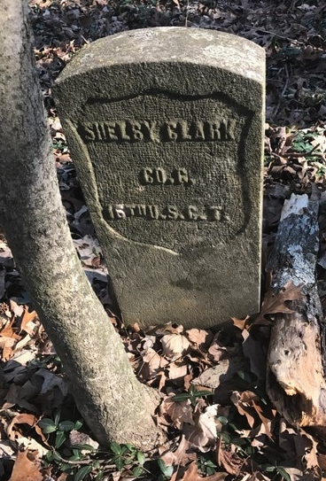
Biography of a Civil War Veteran
SHELBY CLARK
Born in 1842 in Christian County, KY
Enlisted on Jan 15, 1864 in Company G of the 16th USCT at Clarksville, TN. His occupation at the time of enlistment was farmer. He enlisted for a period of 3 years.
He is described at the time of enlistment as 22 years old. He was 5 feet 4 and ½ inches tall with brown eyes and black hair. His complexion is described as copper.
According to the 16th USCT Regimental Records, Company G spent its entire time in Chattanooga, TN, and the time frame indicates that they were on occupation duty since the battle of Chattanooga occurred in Nov 1863 and the battle of Chickamauga occurred in September 1863. Shelby’s Military Records indicate he was not careful with his equipment. In October 1864, he lost his haversack and canteen at a total cost of 85 cents. On the September/October 1865 muster, he is listed as having lost a lampion (a small oil lamp) and a cartage belt plate a total expense of $12. On the January/February 1866 muster, he is listed as having lost by neglect an Enfield R. Musket (cal 58) costing $18.50. Shelby mustered out in Nashville, TN on April 30, 1866. At that time, the Army owed him $8.32.
On October 13, 1867, Shelby married Sarah Wyatt. For the first 15 years after his discharge, Shelby worked moving wheat from one department to another in a mill. One of the granaries he worked at, was owned by Wiliam T. Dorch. He also did general labor at a tobacco factory.
Shelby and Sarah had six children: George born Jan 30, 1868; John born June 29,1872; Lillie born Feb 19, 1876; Shelbina born May 5, 1881; Clarence born Nov 4, 1882; and Lura born Nov 11, 1886.
In 1891, Shelby applied for a pension due to rheumatism which was rejected at first. He made an initial statement in which he originally said the disability started in January of 1874 due to the amount of exposure to the elements sustained doing his job at the granary of William Dorch. The first attack involved his back, left hip and leg causing him to be bedridden for six months. He was disabled again in the fall of 1876 for three months and periodically disabled from that point until the end of his life. His first application was rejected due to the disability occurring after he left the army. He reapplied, and this time stated that the rheumatism was as a result of exposure to the elements while he was stationed in Nashville. He was awarded a pension of $12 a month.
Shelby’s wife, Sarah, died either April 4 or April 6, 1891. There is a statement by George Vance (also buried in our cemetery) who states he was the sexton of Olive City Cemetery and buried her on April 6, 1891. The only record I could find of her was the 1880 Census. There is also a statement by Vicie Oakley that Sarah was a member of a lodge called “The Household of Ruth” at the time of her death and that the lodge buried her.
On April 16, 1893, Shelby Clark died of consumption. He was 54 years old. He left behind 5 living children. Four of the children were less than 18 years old when he died.
In 1894, an application for a minor’s pension was made on behalf of those four children by Cube Steele, a neighbor. Before the application process was through, one of the children reached the age of 18. Shelbina married Julien Bell on Nov 1, 1895 when she was 14 years old. Lura married Jas Martin on July 9, 1902 when she was 16 years old. By 1905, she and Jas were living in Evensville, Indiana. The 1900 Census lists Clarence age 18 living in Cube Steele’s household. His occupation is Tobacco Factory Laborer. It lists his relationship to Cube Steele as nephew. So far I have not found the two older children, John and Lillie except for their mention in the 1880 Census.

