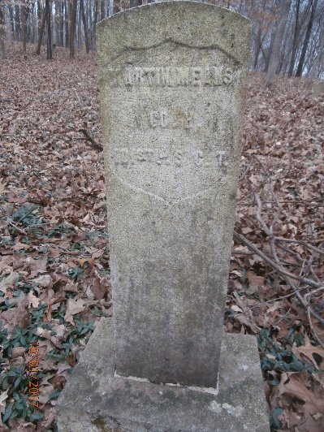
Martin and Macie Means Biography
Both Martin and Macie Means were born in Christian County, Kentucky and belonged to slave-owners who were neighbors and very likely friends. Martin was born in 1833 and Macie was born probably about 1840. Martin belonged to Samuel Means and Macie belonged to Robert Brenaugh. An indication of the fact that the slave-owners were friends is that on September 15, 1855 Martin Means and Macie Brenaugh were married in Robert Brenaugh’s house by Isaac Gains, a black Baptist minister. They were allowed to live together as man and wife. In order to marry and live together, both slave-owners would have to agree to the marriage and living arrangements.
Regardless of how good their living arrangements were, Martin left and went to Clarksville, Tennessee and enlisted in Company H, 101st USCT on July 26, 1864 for 3 years. The 5 foot 7 inch Martin is described as being 31 years old with black eyes and hair and having a brown complexion. In his pension record a former fellow slave described him as “a large man, very fat and robust and who was regarded as Means’ stoutest slave.” His occupation was listed as farmer, and he was paid a $300 bounty for enlisting.
Martin was very lucky in his choice of units. Company H spent almost its entire existence in Clarksville and it is not credible that he would not have moved his family to Clarksville. When the company moved from Clarksville to Carthage, Tennessee in April 1865, Martin was placed on detached duty starting on March 2, 1865 to guard Regimental Headquarters in Clarksville. He returned to duty with the unit when it returned to Clarksville in May 1865. In July/August 1865, Company H was in Nashville and Martin was with it. During this time, the Army paid him $100 on his bounty. By September/ October 1865, Company H was back in Clarksville. Martin was mustered out on January 24, 1866 in Nashville. The government owed him $7.23.
Martin returned to Clarksville by 1870. He is listed on that census with Mary Means age 16. There is no indication as to where Macie is until the 1880 census when the three if them were living at 358 College Street with two other large families. Both censuses list Martin’s occupation as laborer. In subsequent censuses, Macie is listed as having had two children. One of her children married Andrew W. Roberts and is referred to as Annie by Macie. It is probable from the dates of the children born to this marriage that Mary and Annie are the same person. There is no record of the date of this marriage but before he died, Martin and Macie were living with the Roberts at 1112 Commerce Street. By 1890, Martin is described as a cripple who could hardly walk from rheumatism in his shoulder and right arm and hip. From November 1890 he was lame and frequently confined to bed and was also treated for heart disease. From this point on he was unable to work. Macie took in washing and ironing.
On February 1, 1892, Martin applied for an invalid pension citing rheumatism, heart problems, and vision problems stemming from his service. His doctor’s deposition in support of Macie’s widow’s pension states that on May 5, 1892, Martin suffered a stroke that caused paralysis. Ironically, Martin was dressing to go to Nashville for an examination for his pension when he was stricken. Martin Means died on June 1, 1892 at his son-in-law’s house.
Macie applied for a widow’s pension on June 30, 1892. And after at least one rejection, finally received a pension of $8 per month. Her daughter died June 26, 1899 leaving behind 11 children ranging from age from 23 to 2 years of age. Macie became very involved in helping to take care of her grandchildren. By the 1910 census, there were still eight children at home. Macie died on January 11, 1915 of lumbago. Her son-in-law, Andrew W. Roberts filed for reimbursement for her burial expenses. The invoices he submitted to the pension office listed $4.85 for the physician and $154 for nursing care during Macie’s last illness. Nace Dixon’s firm charged $81 and the grave digger charged $2.50.
Both Martin and Macie were buried in Mt. Olive Cemetery.

