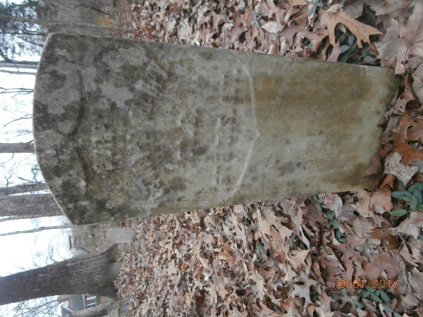
Leonard Mabry Biography
Enlisted in Company B, 16th Regiment of the USCT in Clarksville, TN on November 27, 1863. At that time, he was listed as 40 years of age which makes his birth year 1823. His military records describe him as 5’5’’ tall, dark complexion, and hair and eyes that were black. He was born in Montgomery County, TN and his occupation at enlistment was farmer.
On January 1, 1864, he was promoted to Corporal. By March of 1864, he is demoted back to Private and transferred to the Invalid Corps. In April of 1864, he was sick and listed as absent at Post Hospital in Nashville, TN and returned to the unit in May 1864. Company B, 16th USCT was stationed in Chattanooga, TN He was mustered out April 30, 1866. According to this document, he had pay due from enlistment and owed the government $9.21. In April of 1864, he had lost by carelessness one screw driver costing 46 cents, one ball screw costing 12 cents and one canteen costing 41 cents.
Leonard Mabry earned a Certificate of Disability for Discharge which was given in Chattanooga, TN on May 24, 1864 for “prolapses ami”. His commander Artemas Curtis of Company B, 16th USCT certified that he had been unfit for duty 60 days out of the last 2 months and that his condition was caused or developed by change of diet together with exposure while on duty at Clarksville, TN during the months of January and February 1864 and that he was a good faithful soldier previous to his disease. This certificate of disability allowed him to join the Invalid Corps organizing at Nashville, TN. The certificate also certified that Leonard had not been paid since his enlistment. He then became a member of Company C, 101st USCT on June 27, 1864.
While in the 101st USCT, he was listed as absent sick in General Hospital on the July/August 1864 muster roll and also on September/October 1864 roll. He was detached for duty at the Contraband Camp from December 31, 1864 to August 31, 1865.
In his pension records, it becomes clear exactly what caused all these admissions to the hospital and his eventual transfer to the 101st USCT. While with Company B, 16th USCT he developed a very bad case of diarrhea and camp cough. He also developed an inguinal hernia or rupture (the abdominal wall gives way and allows the intestines to protrude usually caused by severe straining). Leonard Mabry connected this rupture to two things: drilling at Nashville in April 1864 and the severe camp cough and diarrhea he suffered in Chattanooga.
After he left the Army, he worked both as a farmer and laborer using a truss (padded supportive sling) to hold his intestines in place. By 1890, his rupture was so bad he could no longer work and was dependent on charity. He could no longer use a truss because it was too painful. His hernia is described by his neighbors as being the size of two fists put together. He also had pain in all his joints and described his condition as not being able to get out of bed or dress himself without help. He received a pension which at the time of his death was $8 a month.
He died on February 16, 1900. There is no Physician’s Certificate indicating what he died of. There is no record of Leonard Mabry ever marrying, and he had no children.

