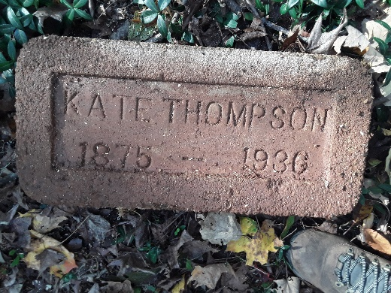
Kate and Dorsey Thompson Biography
About 1875, Alford and Ann Williams were blessed with their second daughter and eighth child who was named Kate. By 1880, the family had grown to six boys and three girls. Sometime between 1880 and 1900, all the men in the family had died. Ann and her three girls were living at 9 Kessee Alley. Ann was a laundress, as was Eddie, aged 22. Kate, aged 26, was working as a cook, and Maggie, aged 28, worked as a hotel servant.
Kate married Dorsey Thompson on July 5, 1906. Dorsey was born in Louisianna in 1866 and worked as a painter. Kate was a housewife except for a brief period in 1920 when she took in washing. They lived on Kessee Alley until about 1929. In 1915, their only son George K. Thompson was born. The 1929 Clarksville City Directory listed them living at Klein’s Alley. The 1930 Montgomery County census listed their address as 32 Klein’s Alley. George was 16 years old and attending school.
On April 9, 1936, Kate and Dorsey both wrote their wills. They left everything to their son George and Annie Larkins. Both wills mentioned their home place as being lot #10 in the Williams Addition in Ward Three and directed that it could not be mortgaged or sold without the consent of Kate’s sister Maggie Gatlin who lived in Dover.
Kate died of complication from diabetes on September 24th, 1936 in Dover probably while visiting her sister. She was buried in Mt. Olive Cemetery by Nace Dixon’s company on September 27th. Dorsey lived another nine months. He died of Mitral Stenoses (a narrowing of the mitral valve opening that blocks blood flow from the left atrium of the heart to the left ventricle) resulting from chronic Nephritis (inflammation of the kidneys) on June 24th, 1937 and was buried in Mt. Olive Cemetery by Nace Dixon’s company on June 27th.
In 2020, Kate’s gravestone was discovered during a cemetery clean-up. Dorsey’s gravestone has yet to be found.

Bibliography
Clarksville, Tennessee City Directory (1911, 1922,1929),
Montgomery County, Tennessee Census (1880, 1900, 1920, 1930).
Will Books: Author: Tennessee County Court (Montgomery County); Probate Place: Montgomery, Tennessee. Will Books, Vol U, 1914-1939.

