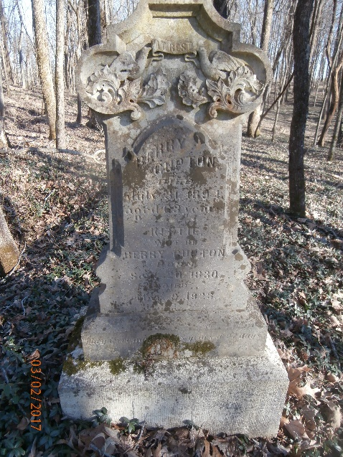
Barry and Kittie Gupton Biography
Very little is known about Barry and Kittie Gupton before the war. The pension record gives little to no personal information on them or their lives. The first records we have on Barry are his military records which show that he joined Company D of the 16th USCT on February 18, 1864 in Clarksville, Tennessee. He was 33 years old and had been born in Christian County, Kentucky in 1831. He was 5 feet 8 inches in height with black hair and eyes and a black complexion. His occupation prior to the Army had been farming.
His service was unremarkable. He did not rise in rank above private and did not loose any of his equipment. On October 19, 1865, like so many other USCT troops, he was given a furlough which he spent in Clarksville. The government charged him $11.80 for transportation to Clarksville and then back to Chattanooga, Tennessee. He returned to the unit in November of 1865. On March 30 and 31, 1866 Barry was treated for a sprain. His record does not specify what part of the body the sprain was in. When he mustered out in Nashville on April 30, 1866, the government owed him $25.23 in pay.
As a member of the 16th USCT, the majority of his time in the Army was spent in Chattanooga on occupation duty. He was in Nashville, Tennessee with his unit for the Battle of Nashville in December of 1864 but did not take part in the battle since the 16th USCT was held in reserve.
After his discharge, Barry returned to Clarksville where on June 3, 1866, he married Kittie Hatcher. On November 19, 1866, George and Ben Pennington were passing the newlywed couple’s house when Ben started “abusing” Kittie. Barry ordered him to leave and to stop mistreating his family. Ben drew a pistol on Barry who snatched it from Ben’s hand. Barry went into the house with the pistol. Ben’s brother, George, followed and attempted to retrieve the gun. When George would not get out of his house, Barry hit him on the head with the pistol killing him. The killing was ruled justifiable homicide. This account was carried in the Clarksville Chronicle.
In the 1870 census, Barry listed his occupation as laborer and a personal estate of $15. Kattie’s occupation is listed as keeping house. His personal estate starts to get interesting after 1870. On March 23, 1871, Barry and Jeff McReynolds bought 4 lots in an auction and divided them between the two of them. On September 20, 1878, Barry bought 5 more lots at auction for $135.
The 1880 census lists Barry’s occupation as carpenter with Kittie listed as keeping house. Jo Ann Oldham is listed in their household as a 10-year-old granddaughter. This is very strange since all accounts state that Barry and Kittie had no children. This granddaughter might have been the product of a relationship that Barry had before the war.
On November 2, 1880, Barry bought the land that Jeff McReynolds kept from the first auction from Jeff’s wife for $105. On November 19, 1881, Barry transferred ownership of eight lots to Kittie.
Barry Gupton first applied for a pension December 13, 1890 and listed his address as 527 Ford Street. He stated that on the march from Nashville to Chattanooga he became exhausted in an effort to keep up with his company and suffered an affliction in his shoulders and breast from carrying his accoutrements that affected him from that time on. Fellow soldiers who gave depositions in support of his application recalled that he had to put his gear in the company wagon. They remember him complaining of pain in his heart and shortness of breath. One of the soldiers who gave a deposition was Stephen Kimbrough who is buried in Mt. Olive Cemetery.
C.V. Roman a doctor living in Clarksville wrote a medical affidavit dated March 8, 1892 for Barry which stated five disabilities:
1. Articular and muscular rheumatism of the chest, shoulders, and knee joints that rendered him unfit to work in damp weather.
2. The heart was weak and circulation was feeble.
3. Atony of the bladder which caused frequent retention of or dribbling of urine.
4. Chronic cough with a decided tendency to asthma.
5. Total deafness in his left ear.
A report dated November 22, 1893 by a doctor who performed examinations for the pension office found that Barry was deaf in his left ear but it wasn’t service connected. An analysis of Barry’s urine failed to find any abnormalities. A light murmur in the aortic opening was found but all other heart valves sounded normal. The doctor saw stiffness in Barry’s movements but no other signs of chronic rheumatism. The verdict of the doctor was: “He is a robust looking man and still capable of performing manual labor.”
Needless to say, they rejected his application. He appealed and was rejected again. He appealed a third time and was finally given a pension of $6 a month for heart and bladder disease starting on November 3, 1893. It ended when he died on July 31, 1894. There is no death certificate, but from the chest pain and shortness of breath reported by everyone who gave a deposition, he probably died of heart disease.
One final thing. In one of the depositions it was stated that Barry was a member of the Order of the GAR. GAR stands for Grand Army of the Republic. This was a veteran’s group for former Union soldiers.
Kittie applied for a widow’s pension on July 15, 1895. All of her depositions deal with her property. When Barry died, he left her 11 lots with small cabins on them. Most of them were in the area of Kellogg Street (now known as 8th Street), Marion Street, and Ford Street. One of the lots was on Martin Street. Most of her statements on the properties are confusing because she was trying to make the case that she did not receive much income from them. She stated that she owned 16 lots with 14 tenement houses valued at $2,880. Two of the 16 lots were vacant lots. The taxable value of her husband’s estate was $2,500. She stated she paid $73 for three years on 12 tenement houses and $11 for three years on the house she lived in. After expenses she claimed that her income from the rent of these houses was $20.50 per month. The pension record is unclear about when she started receiving a pension but a note dated September 8, 1916 increased her pension to $20 per month.
The 1910 census lists Kittie living alone at 527 Marion Street with no occupation listed, but the 1911 Clarksville City Directory lists her as having the occupation of Laundress. In the 1920 census her house number changed from 527 to 825 Marion Street and no occupation listed.
Kittie died on March 10, 1923 of senility. She was 95 years old. All her property was left to her brother John Wesley Williams and his children. She directed that $100 be used for her funeral expenses. According to the estate accounts, S.A. Dabney was paid $309 for “one burial outfit”. This was probably the total expense for funeral, burial, and headstone. She and Barry are buried in Mt. Olive Cemetery under one of the most beautiful gravestones in the cemetery.
Six people had valid claim to her estate. Each one received $12.72 in cash from the estate and the real estate property was split between them. At the time of her death, Kittie was receiving $30 per month from her widow’s pension.
825 Marion Street exists as an address today. The property was appraised in 2019 at $76,100.

